Basic Shell Scripts:

* Output to screen

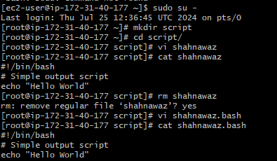

* Defining Tasks

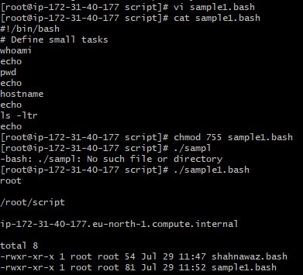

* Defining variables

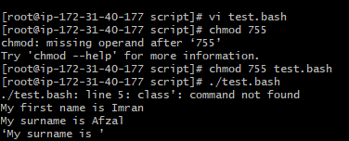

* Read Input

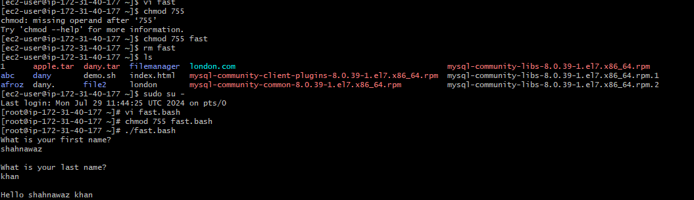

* Scripts to run commands within

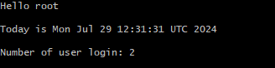

* Read input and perform a task

